Multiple choice section

Question 1 [10.2]

When figure I is transformed to figure II, the type of transformation is a:

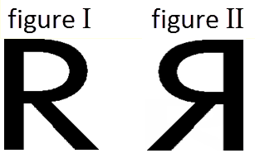

A reflection B rotation

C dilation D none of the above

Question 2 [10.1]

A transformation can consist of:

A a translation B a rotation

C a reflection D any of the above.

Question 3 [10.4]

A combined transformation can consist of:

A a translation of 5 units up and 2 units down

B a rotation of 50% clockwise and 90% anticlockwise

C a translation of 5 units up and a rotation of 50% clockwise

D none of the above

Question 4 [10.5]

Which of the following characters possess only one axis of symmetry?

A B C F J K H

A A B C B F J K

C A B H D None of the above.

Question 5 [10.7]

What is the meaning of the number 4 in the mat plan shown below?

|  |  |  |
| --- | --- | --- |
| 4 | 3 | 1 |
| 2 | 2 |  |

A The volume of the cube placed in the square displaying the number 4.

B The surface area of the cube placed in the square displaying the number 4.

C There are 4 cubes stacked in that position.

D None of the above.

Question 6 [10.3]

A clockwise rotation of 72° is equal to:

A an anticlockwise rotation of 72°

B a clockwise rotation of 108°

C an anticlockwise rotation of 288°

D a clockwise rotation of 288°

Question 7 [10.1]

The reverse translation of 5 units left and 6 units up is:

A 5 units left and 6 units down

B 5 units right and 6 units down

C 5 units right and 6 units up

D 6 units left and 5 units up

Question 8 [10.5]

Which of the following statements is true for a regular pentagon?

A Its order of rotation is 5.

B It has 5 axes of symmetry.

C It possesses both rotational and reflectional symmetry.

D All of the above.

Multiple-choice total marks: ____ / 8

Short answer section

Question 9 2 marks [10.5]

Name any two types of quadrilateral that possess exactly one axis of symmetry.

Question 10 2 marks [10.3]

Describe the process when an object is rotated. Use an example to help you explain.

Question 11 2 marks [10.1]

Describe the translation shown in the diagram.

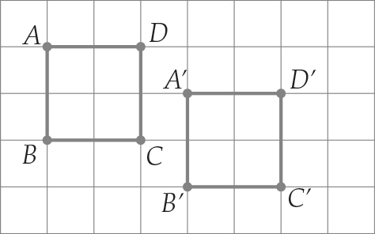

Question 12 3 marks [10.1]

Perform the following translation:

14 units left and 4 units down.

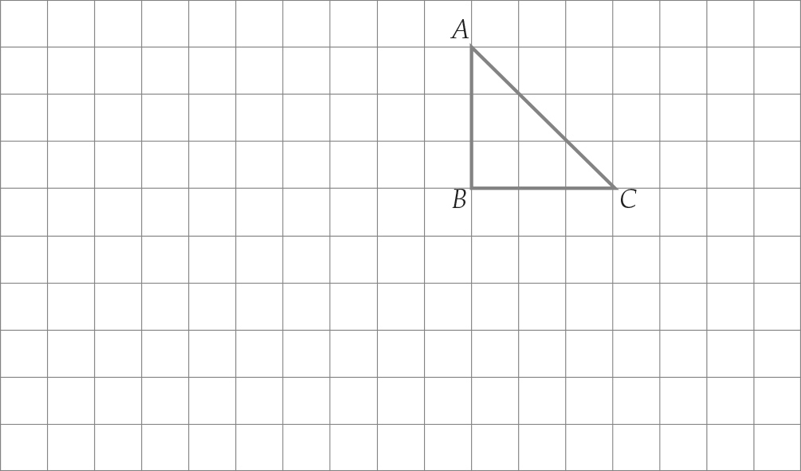

Question 13 6 marks [10.2]

(a) Use the Cartesian plane below to plot the points A (2, 5), B (6, 5) and C (4, 9), and then join the points to form a triangle.

(b) Translate the triangle 3 units left, 6 units down and then a further 3 units left and 2 units down. Label the translated figure with correct notation.

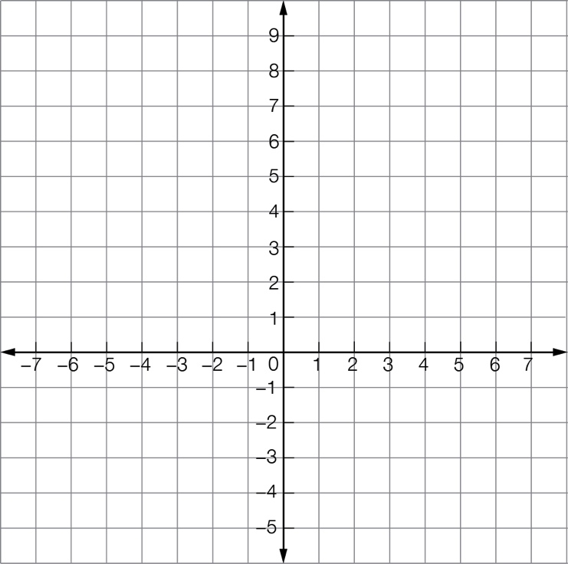

(c) What are the coordinates of the translated figure?

Question 14 2 marks [10.2]

Draw the resulting image when the quadrilateral is reflected in the line of reflection shown.

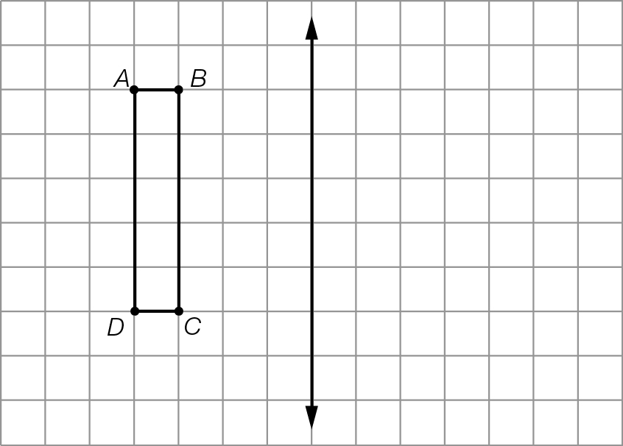

Question 15 2 marks [10.3]

Rotate 270° in a anticlockwise direction about 0.

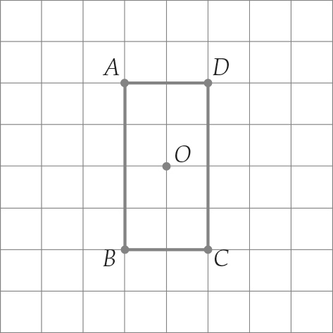

Question 16 2 marks [10.5]

How many axes of symmetry do the following objects have?

(a)  (b) 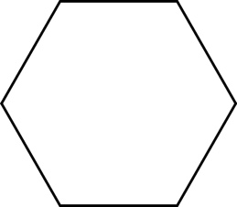

Question 17 2 marks [10.5]

Use the dashed line as the axis of symmetry to complete the diagram on grid paper.

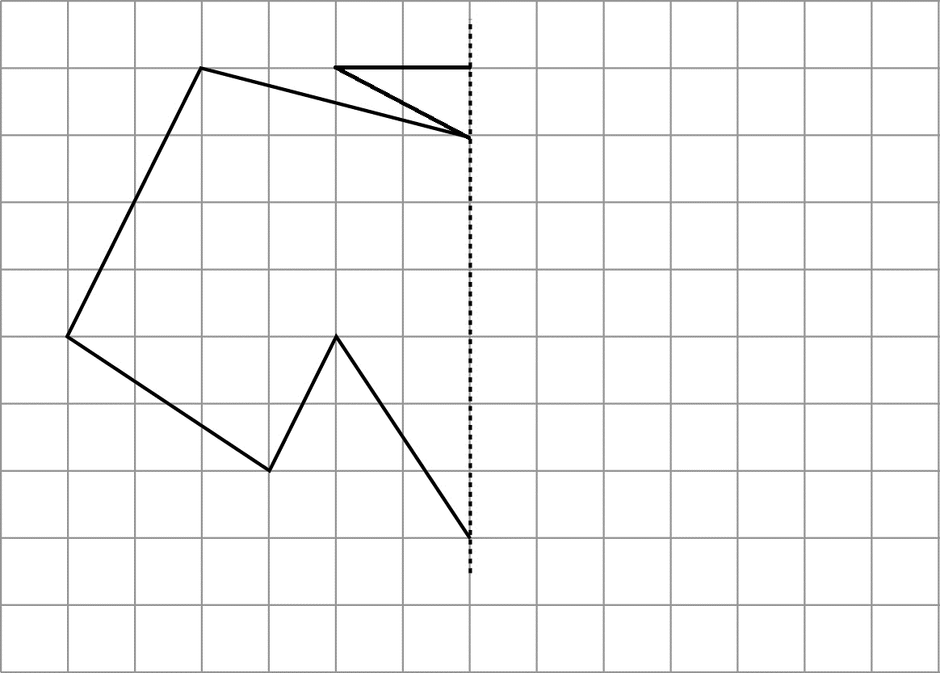

Question 18 4 marks [10.5]

Below are three figures. Figure 1 is a photograph of a dog’s face. It is not symmetrical. The images in Figure 2 and Figure 3 are symmetrical and were made from Figure 1. A vertical line going through the centre of Figure 2 forms an axis of symmetry. The same is true for Figure 3.

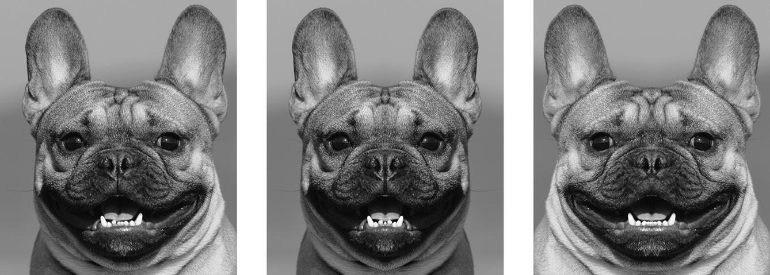

Figure 1 Figure 2 Figure 3

(a) Explain how Figure 2 was obtained from Figure 1.

(b) Explain how Figure 3 was obtained from Figure 1.

Question 19 1 marks [10.6]

How many cubes in the following solid? (Assume that there are no cubes missing at the back of the solid where you cannot see.)

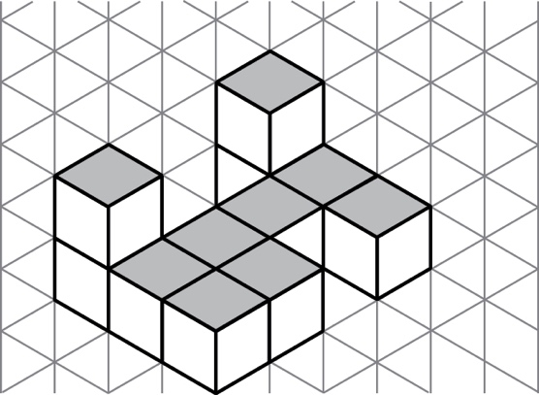

Question 20 2 marks [10.7]

Draw a 3D sketch of the following.

Top Front Side

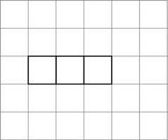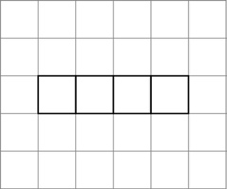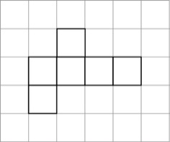

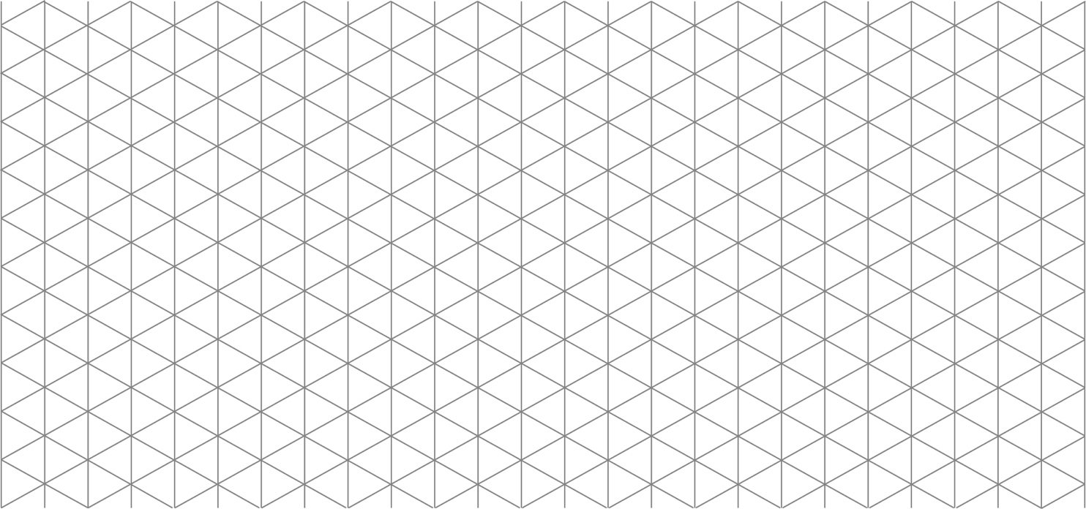

Question 21 3 marks [10.7]

For the following solid, draw the views below.  
(Assume there are no cubes missing at the back of the solid where you cannot see).

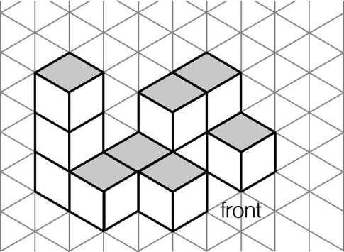

|  |  |  |
| --- | --- | --- |
| (a) top view | (b) front view | (c) side view |

Question 22 4 marks [10.7]

Draw the following mat plan as a 3D shape on the isometric grid below.

|  |  |  |
| --- | --- | --- |
| 4 | 3 | 1 |
| 2 | 2 |  |
| 2 |  |  |

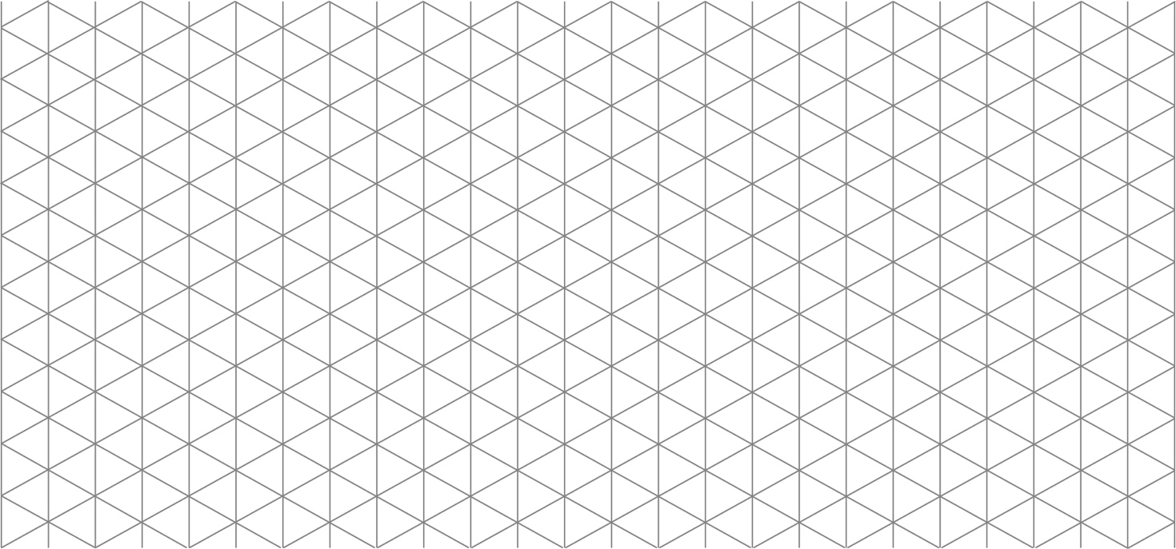

Short answer total:_______ /37

Extended answer section

Question 23 3 marks [10.4]

Describe the transformations that have taken place to move the square to the grey position, then to the black position.

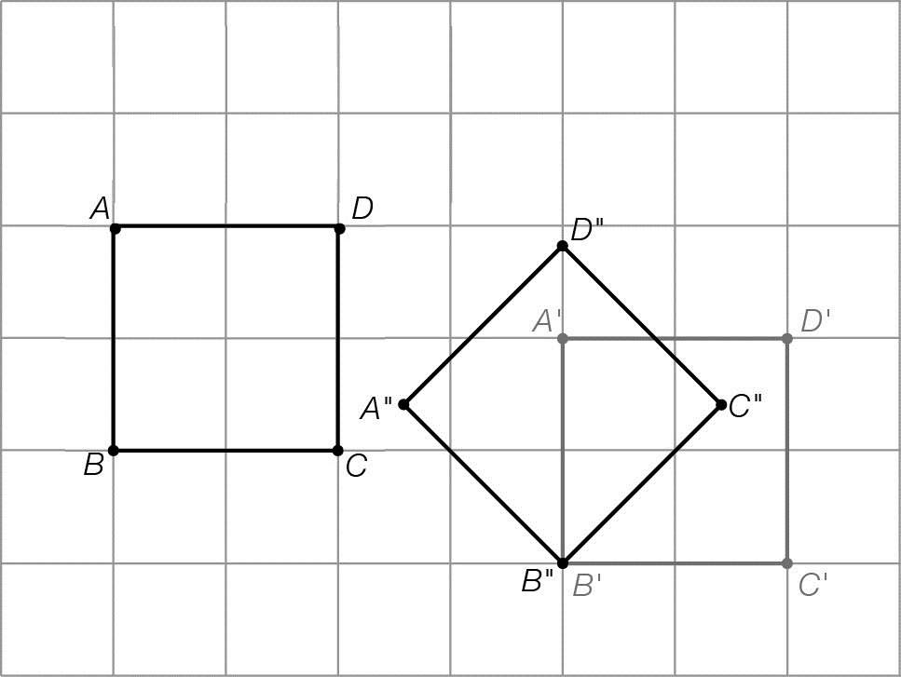

(a) Transformation 1

(b) Transformation 2

Question 24 4 marks [10.5]

The number 1 000 001 has reflectional symmetry when written in a sans-serif typeface as shown. The location of the axis of symmetry is shown below.

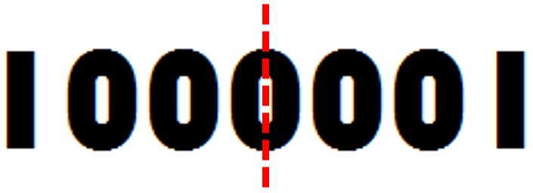

List an four numbers between 8 000 000 and 9 000 000 that exhibit reflectional symmetry. You can only use the digits ‘8’ and ‘0’ to construct your answers.

Question 25 6 marks [10.4]

The grid below contains four pictures. The position of each picture or panel can be described using a letter and a number. For example:

* the location of the top left picture is described as A1
* the location of the bottom right picture is described as B2.

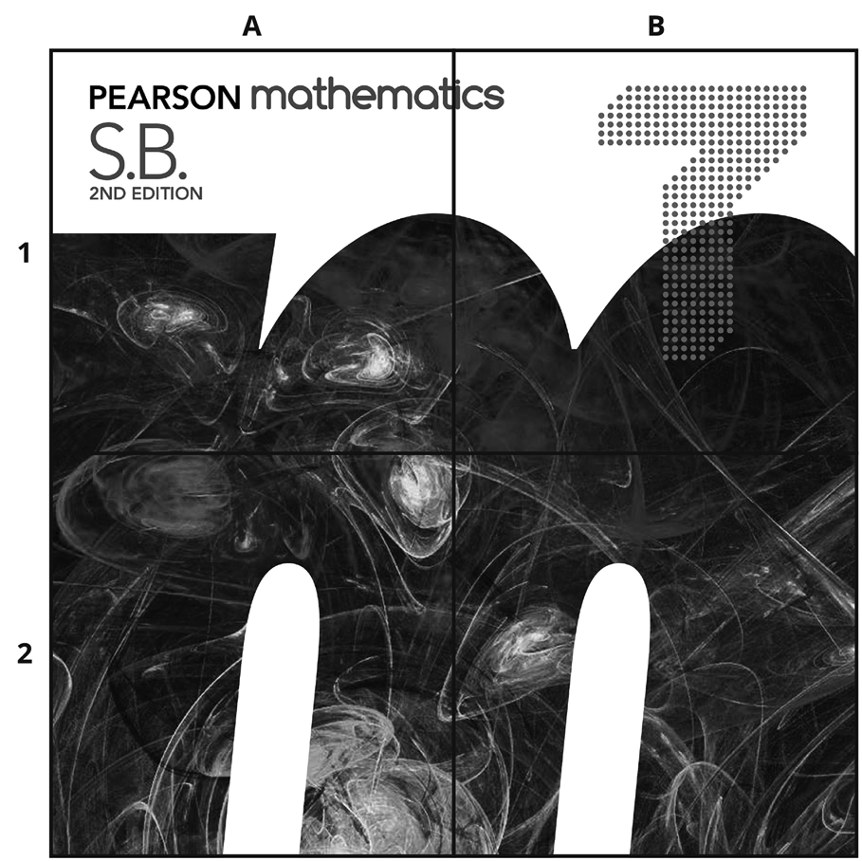

The pictures undergo translations and/or rotations and the original overall image is scrambled.

Referring to each picture by its location using a letter and a number, describe what sort of combined transformation needs to occur to restore the overall image to its original form.

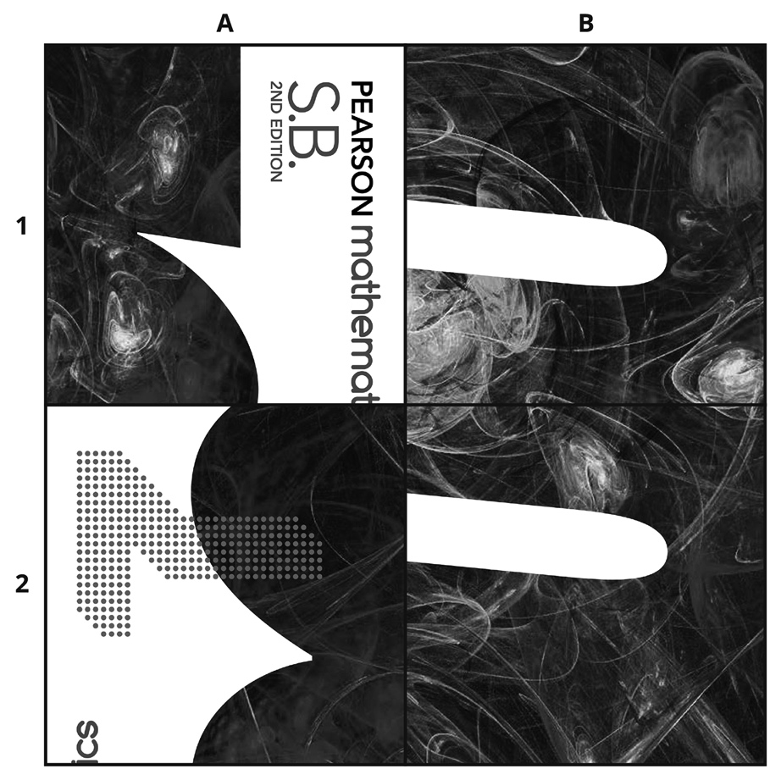

Question 26 6 marks [10.2]

(a) Use the Cartesian plane below to plot the points A(1, 3), B(3, 3) and C(1, 6), and then join the points to form a triangle. Label *ABC*.

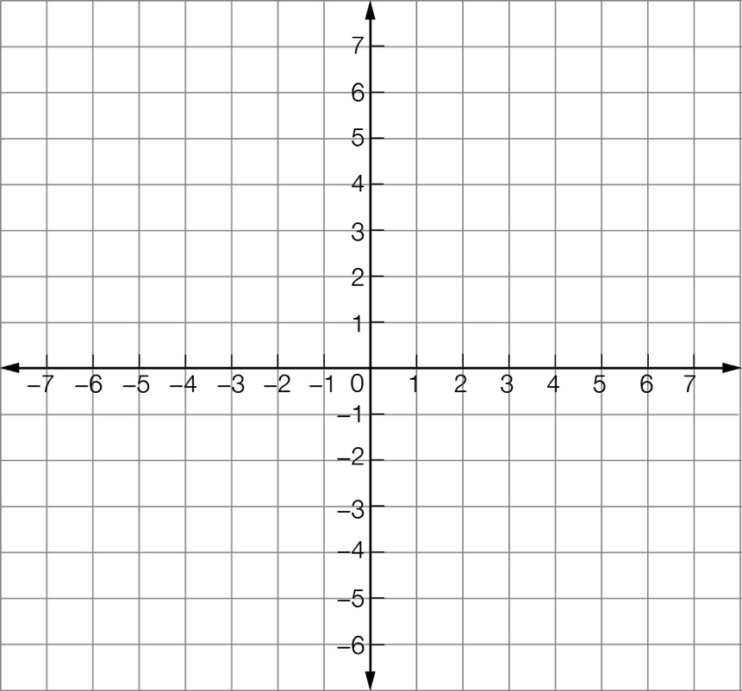

(b) Reflect the triangle in the x-axis. Label this triangle A’B’C.’

(c) Now reflect this triangle first in the y-axis. Label this triangle A’’B’’C’’.

(d) What are the coordinates of the translated figure?

Extended answer total:_______ /19

TOTAL test marks: _______ / 64